# While Loops

## Question: 1

Why do we use while loops?

To repeat code a specific number of times

To use if-else statements in a loop

To repeat code when the number of times to repeat is unknown

To determine if a condition is true

## Question: 2

How is an infinite loop created?

By using an infinite value in a for loop

By using an infinite value in a while loop

By using a condition that will never become false in a for loop

By using a condition that will never become false in a while loop

## Question: 3

What will happen when this code is run?

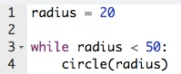

Tracy will draw 1 circle with a radius of 20.

Tracy will draw 50 circles with a radius of 20.

Tracy will draw 20 circles with a radius of 50.

An infinite loop will occur.

## Question: 4

What will the output of the following code be?

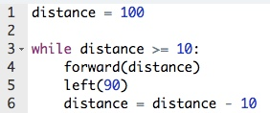

1. 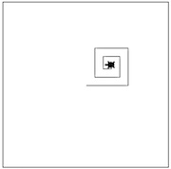
2. 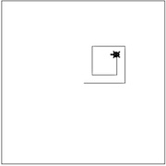
3. 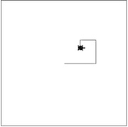
4. An infinite loop will be created.